
While driver ratings are commonly considered a major determinant of customer satisfaction and retention, Lucknow and Surat present an interesting business scenario. Despite recording comparatively lower driver ratings, both cities demonstrate some of the highest repeat passenger rates. This analysis investigates the underlying factors that may contribute to this unexpected outcome and identifies what truly drives customer loyalty.

Why do Lucknow and Surat have the highest retention despite having some of the lowest driver ratings?

- Does driver rating influence retention?

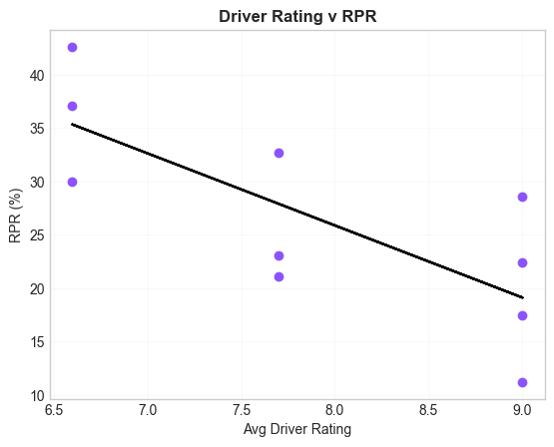

  - Hypothesis Testing:
- Null Hypothesis (H₀): There is no relationship between driver rating and repeat passenger rate.
- Alternative Hypothesis (H₁): There is a relationship between driver rating and repeat passenger rate.

  - Results
- Correlation: -0.7564290281153278
- P-value: 0.011338670950622132
- There is a statistically significant relationship between driver rating and repeat passenger rate.

Conclusion: Statistical analysis revealed a significant negative correlation between average driver ratings and repeat passenger rates (r = -0.756, p = 0.011). This suggests that customer retention is likely influenced by factors beyond driver experience alone, such as trip frequency, pricing, and travel behavior.

- Does fare influence retention?
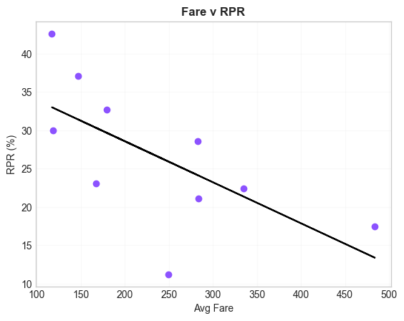
  - Hypothesis Testing:
- Null Hypothesis (H₀): Average fare has no relationship with repeat passenger rate.
- Alternative Hypothesis (H₁): Average fare has a relationship with repeat passenger rate.

  - Results
- Correlation: -0.6542989912209133
- P-value: 0.040113467387727364
- Cities with lower average fares tend to have higher repeat passenger rates.

Conclusion: Statistical analysis revealed a significant negative correlation between average fare and repeat passenger rate (r = -0.654, p = 0.040). Cities with lower average fares generally exhibited higher customer retention, suggesting that affordability may play an important role in encouraging repeat usage.

- Does fare influence retention?
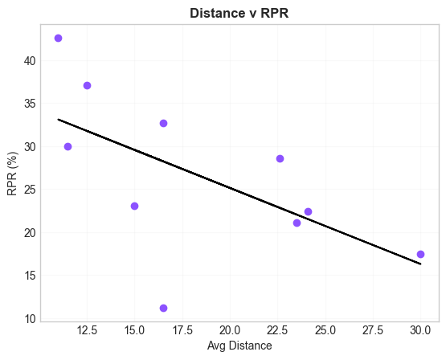

  - Hypothesis Testing:
- Null Hypothesis (H₀): Average distance has no relationship with repeat passenger rate.
- Alternative Hypothesis (H₁): Average distance has a relationship with repeat passenger rate.

  - Results
- Correlation: -0.5985961280120558
- P-value: 0.06749621804295085
- The analysis found a moderate negative relationship between distance and repeat passenger rate, but the relationship was not statistically significant at the 95% confidence level.

Conclusion: Statistical analysis was conducted to identify factors associated with customer retention. Driver ratings (r = -0.756, p = 0.011) and average fare (r = -0.654, p = 0.040) showed significant negative relationships with repeat passenger rate, while average trip distance demonstrated a moderate negative relationship that was not statistically significant (r = -0.599, p = 0.067). These findings suggest that customer retention patterns vary substantially across cities and may be influenced by broader travel behavior and market characteristics rather than service quality metrics alone.

- Why do Lucknow and Surat have the highest retention despite having some of the lowest driver ratings?

To investigate why Lucknow and Surat achieved the highest retention despite lower driver
ratings, a comparative analysis was conducted between high-retention and low-retention cities. The comparison is as follows:

Metric | Surat | Lucknow | Indore | Chandigarh | Jaipur | Mysore
total_  passengers | 202642 | 58572 | 20792 | 39785 | 55381 | 13158
repeat_  passengers | 86389 | 21836 | 6797 | 8404 | 9653 | 1477
rpr (%) | 42.63 | 37.12 | 32.68 | 21.14 | 17.43 | 11.23
avg_distance (km) | 11.0 | 12.5 | 16.5 | 23.5 | 30.0 | 16.5
avg_fare (₹) | 117.3 | 147.2 | 179.8 | 283.7 | 483.9 | 249.7
avg_driver_  rating | 6.6 | 6.6 | 7.7 | 7.7 | 9.0 | 9.0
pct_repeat_  passengers_  with_more_  than_5_  trips (%) | 58.07 | 58.27 | 28.06 | 30.91 | 16.04 | 13.61
weekend_trip_rate (%) | 31.09 | 22.83 | 50.07 | 48.91 | 57.74 | 60.44

  - Lower Fares Encourage Frequent Usage
- Surat and Lucknow recorded the lowest average fares at ₹117 and ₹147 per trip.
- Jaipur's average fare was ₹484, more than four times higher than Surat's.
- Lower fares reduce the cost barrier for repeat usage, making the service more accessible for regular travel needs.
- Correlation analysis further supported this observation, showing a statistically significant negative relationship between average fare and Repeat Passenger Rate.

  - Shorter Trip Distances Support Habitual Travel
- Surat and Lucknow had the shortest average trip distances, at 11 km and 12.5 km respectively.
- Jaipur and Chandigarh recorded much longer average trip distances, reaching 30 km and 23.5 km.
- Shorter trips are more likely to be integrated into customers' daily routines, resulting in higher repeat usage.
- Although distance showed a moderate negative relationship with retention, the statistical test did not achieve significance at the 95% confidence level.

  - High Concentration of Frequent Riders
- The strongest differentiator between high-retention and low-retention cities was the proportion of repeat passengers taking more than five trips per month.
- In Surat and Lucknow, approximately 58% of repeat passengers completed more than five trips per month.
- In comparison, Jaipur and Mysore recorded only 16% and 14%, respectively.
- This suggests that retention is primarily driven by a large base of frequent users rather than occasional riders.

  - Stronger Weekday Demand Patterns
- Weekend trips accounted for only 31% of trips in Surat and 23% in Lucknow.
- In contrast, Jaipur and Mysore had weekend trip shares of 58% and 60%, respectively.
- This indicates that demand in Surat and Lucknow is concentrated during weekdays, suggesting recurring travel behavior throughout the week.
- Cities with stronger weekday demand appear to exhibit higher retention levels than cities that rely heavily on weekend demand.

Conclusion: The analysis suggests that customer retention in Lucknow and Surat is driven more by travel behavior and usage patterns than by driver ratings alone. These cities benefit from lower fares, shorter trip distances, a substantially larger proportion of frequent riders, and stronger weekday demand. Together, these factors indicate that customers are using GoodCabs as part of their regular transportation routine, leading to higher retention despite lower driver ratings.
Business Implication: To improve retention in lower-performing cities such as Jaipur and Mysore, GoodCabs should focus on increasing ride frequency and encouraging habitual usage. Potential strategies include commuter-focused plans, ride bundles, loyalty programs, and targeted incentives designed to convert occasional riders into frequent users.

